Sowing Seeds of Justice
2011-2014

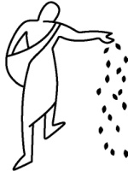

Year I The Sower – Jesus is Sower and models how each one of us is called to be a Sower for others.

Scripture: 2Cor 9:10-15; Mk 4:1-9; Mk 4: 13-20

Year II The Seeds – The Seed(s) that we plant are the word(s) of God; the Good News of Salvation.

Scripture: Is 6:9-10; Mk 13:4-9; Mt 13:18-23

Year III The Soil – The Soil is the fertile ground we need to prepare for the seed to grow. It is a metaphor for the heart of the people and our Catholic school community.

Scripture: Is 55:10-11; Lk 8:11-15; Mk 4:3-9

